STOCK PERFORMANCE ANALYSIS

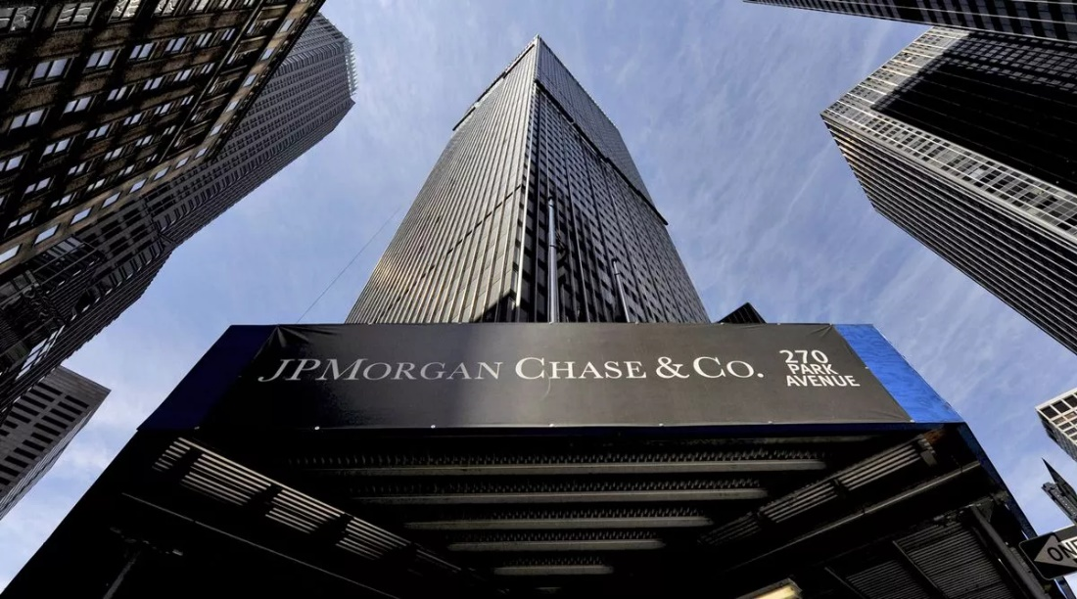

* Industry: Financial Services
* General Overview :

JPMorgan Chase & Co. is one of the largest and most prominent financial institutions globally. It operates in various segments of the financial services industry, including investment banking, asset management, commercial banking, and retail banking. The company provides a wide range of financial services to consumers, businesses, governments, and institutions worldwide. JPMorgan Chase & Co. is a multinational investment bank and financial services company headquartered in New York City. It is one of the largest and most influential financial institutions globally, offering a broad range of financial services to consumers, corporations, governments, and institutions.

Global Presence:

JPMorgan Chase operates a vast global network with offices and branches in numerous countries and regions worldwide. It serves millions of customers and clients across diverse markets, maintaining a significant presence in major financial centers.

Key Businesses:

1.Investment Banking: JPMorgan Chase provides investment banking services, including advisory, underwriting, and financing solutions, to corporations, governments, and institutional clients.

2.Asset Management: The company offers asset management services to institutional and retail clients, managing investment portfolios, providing wealth management, and offering retirement planning solutions.

3.Commercial Banking: JPMorgan Chase serves large corporations, small businesses, and governments with commercial banking services, including lending, treasury services, and cash management solutions.

4.Retail Banking: Through its retail banking segment, the company provides banking products and services to consumers and small businesses, such as deposits, loans, credit cards, and mortgage lending.

* Financial Performance:

JPMorgan Chase is renowned for its strong financial performance and stability. It consistently ranks among the largest and most profitable banks globally, with impressive metrics in terms of revenue, net income, assets under management, and return on equity.

* Leadership:

The company is led by a team of experienced executives, with Jamie Dimon serving as the Chairman and CEO. Dimon is widely respected in the financial industry and is credited with steering JPMorgan Chase through various economic cycles and challenges.

Corporate Responsibility:

JPMorgan Chase is committed to corporate responsibility and sustainability, engaging in philanthropic initiatives, community development projects, and environmental sustainability efforts. It aims to create positive social impact and support sustainable economic growth through its business operations and initiatives.

Regulatory Environment:

As a major financial institution, JPMorgan Chase operates in a highly regulated environment. It is subject to oversight from various regulatory bodies and compliance with banking regulations, financial laws, and industry standards.

This overview provides a snapshot of JPMorgan Chase & Co., highlighting its key businesses, global presence, financial performance, leadership, corporate responsibility, and regulatory environment. It is a leading player in the financial services industry, known for its comprehensive range of services and strong market position.

* HISTORICAL PRICE DATA :

|  |  |
| --- | --- |
| Previous Close | **199.52** |
| Open | **199.49** |
| Bid | **200.03 x 800** |
| Ask | **200.44 x 900** |
| Day's Range | **198.54 - 200.72** |
| 52 Week Range | **126.22 - 200.72** |
| Volume | **8,574,293** |
| Avg. Volume | **9,059,313** |
| Market Cap | **576.938B** |
| Beta (5Y Monthly) | **1.13** |
| PE Ratio (TTM) | **12.35** |
| EPS (TTM) | **16.22** |
| Earnings Date | **Apr 12, 2024** |
| Forward Dividend & Yield | **4.60 (2.30%)** |
| Ex-Dividend Date | **Apr 04, 2024** |
| 1y Target Est | **182.87** |

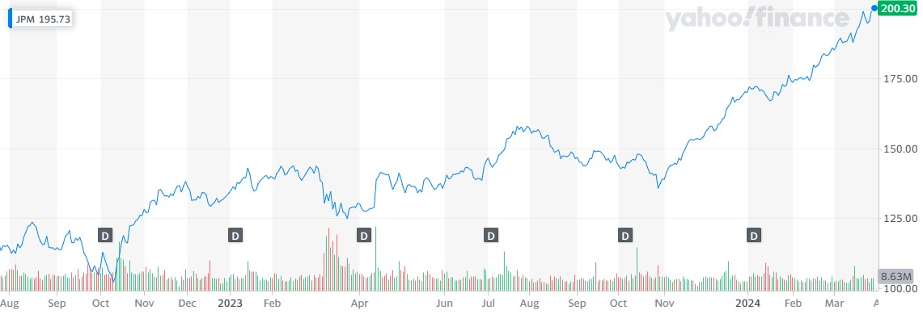

Historical stock price data chart

KEY METRICS:

Historical daily share price chart and data for JPMorgan Chase since 1983 adjusted for splits and dividends. The latest closing stock price for JPMorgan Chase as of March 28, 2024 is 200.30.

The all-time high JPMorgan Chase stock closing price was 200.30 on March 28, 2024.

The JPMorgan Chase 52-week high stock price is 200.72, which is 0.2% above the current share price.

| **JPMorgan Chase Historical Annual Stock Price Data** | | | | | | |
| --- | --- | --- | --- | --- | --- | --- |
| **Year** | **Average Stock Price** | **Year Open** | **Year High** | **Year Low** | **Year Close** | **Annual % Change** |
| 2024 | 180.4100 | 171.0323 | 200.3000 | 167.0900 | 200.3000 | 18.48% |
| 2023 | 141.6572 | 130.4094 | 169.2632 | 121.4460 | 169.0644 | 30.63% |

The JPMorgan Chase 52-week low stock price is 126.22, which is 37% below the current share price.

The average JPMorgan Chase stock price for the last 52 weeks is 154.72.

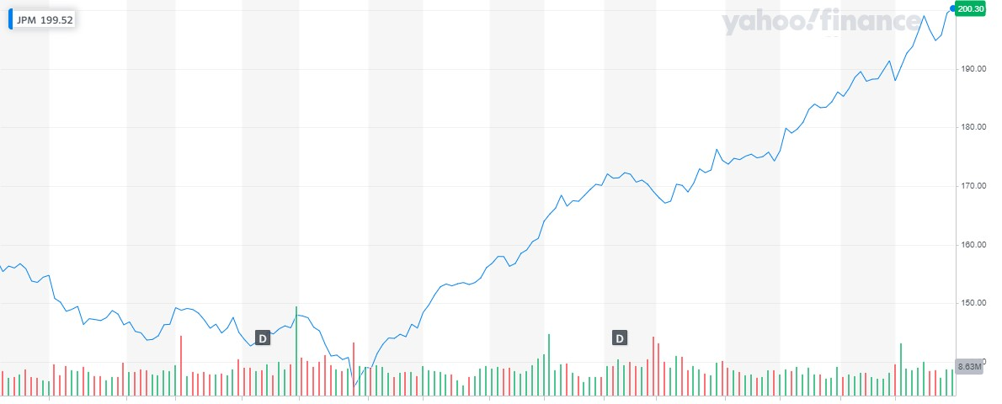

STOCK PRICE CHANGE CHART

VOLATILITY

JPMorgan Chase appears to be very steady, given 3 months investment horizon. [JPMorgan Chase](https://www.macroaxis.com/investing/JPM) holds Efficiency (Sharpe) Ratio of 0.31, which attests that the entity had a 0.31% return per unit of volatility over the last 3 months. We have found thirty [technical indicators](https://www.macroaxis.com/technical-analysis/JPM/JPMorgan-Chase-Co) for JPMorgan Chase, which you can use to evaluate the volatility of the firm. Please utilize JPMorgan Chase's [risk adjusted performance](https://www.macroaxis.com/invest/technicalIndicator/JPM/Risk-Adjusted-Performance) of 0.1958, and Market Risk Adjusted Performance of 0.3508 to validate if our risk estimates are consistent with your expectations. **Key indicators related to JPMorgan Chase's volatility include:**

|  |  |  |
| --- | --- | --- |
| **360 Days Market Risk**  [Very steady](https://www.macroaxis.com/volatility/JPM/JPMorgan-Chase-Co) | **Chance Of Distress**  [Low](https://www.macroaxis.com/financials/JPM/JPMorgan-Chase-Co) | **360 Days Economic Sensitivity**  [Follows the market closely](https://www.macroaxis.com/stocks/beta/JPM) |

JPMorgan Chase Stock volatility depicts how high the prices fluctuate around the mean (or its average) price. In other words, it is a statistical measure of the distribution of JPMorgan daily returns, and it is calculated using variance and standard deviation. We also use JPMorgan's beta, its [sensitivity to the market](https://www.macroaxis.com/invest/beta/JPM), as well as its odds of financial distress to provide a more practical estimation of JPMorgan Chase volatility.

|  |  |  |  |  |
| --- | --- | --- | --- | --- |
| **JPMorgan Beta** |  |  |  | [**0.81**](https://www.macroaxis.com/financials/JPM/JPMorgan-Chase-Co) |

JPMorgan standard deviation measures the daily dispersion of prices over your selected time horizon relative to its mean. A typical volatile entity has a high standard deviation, while the deviation of a stable instrument is usually low. As a downside, the standard deviation calculates all uncertainty as risk, even when it is in your favor, such as above-average returns.

|  |  |  |  |  |
| --- | --- | --- | --- | --- |
| **Standard Deviation** |  |  |  | **0.84** |

It is essential to understand the difference between upside risk (as represented by JPMorgan Chase's standard deviation) and the downside risk, which can be measured by semi-deviation or downside deviation of JPMorgan Chase's daily returns or price. Since the actual investment returns on holding a position in JP morgan stock tend to have a non-normal distribution, there will be different probabilities for losses than for gains. The likelihood of losses is reflected in the downside risk of an investment in JPMorgan Chase.

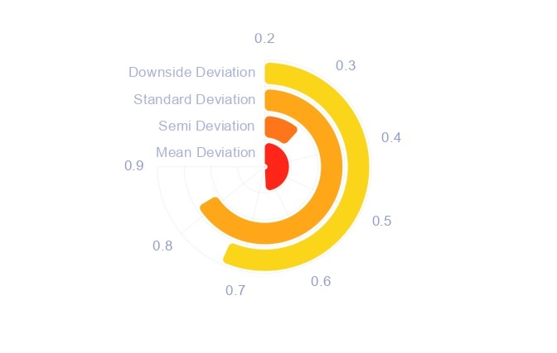

AVERAGE TRADE VOLUME:

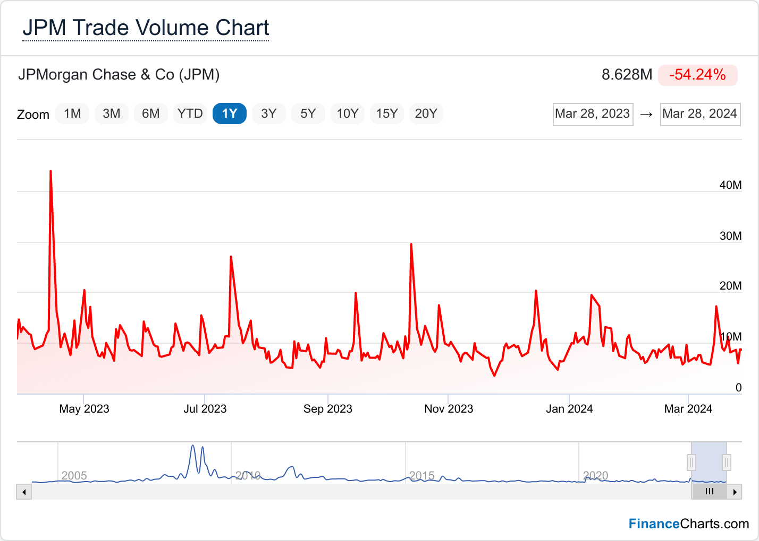

AVERAGE TRADE VOLUME OF JP MORGAN

STOCK COMPARISON AND ANALYSIS :

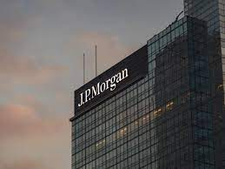 VS

|  |
| --- |
| **Price Information** |
| Exchange | NYSE | NASDAQ |
| Open | 20.08 | 57.38 |
| High | 20.22 | 57.46 |
| Low | 19.86 | 57.00 |
| Last | 20.13 | 57.07 |
| Change | -0.03 | +0.11 |
| % Change | -0.15% | +0.19% |
| Volume | 223,006 | 12,833 |
| 20-Day Average Volume | 203,661 | 29,997 |
| Previous Close | 20.16 | 56.96 |
| Industry | N/A | N/A |
| Has Options | No | Yes |

Price Information

PERFORMANCE :

5 days

|  |  |  |
| --- | --- | --- |
| %Chg | +0.25% since 03/22/24 | +1.95% since 03/22/24 |
| Low | 19.76 on 03/26/24 | 55.92 on 03/27/24 |
| High | 20.23 on 03/28/24 | 57.46 on 04/01/24 |

|  |  |  |
| --- | --- | --- |
| %Chg | +1.10% since 03/01/24 | -0.47% since 03/01/24 |
| Low | 19.76 on 03/26/24 | 55.34 on 03/19/24 |
| High | 20.48 on 03/13/24 | 58.25 on 03/08/24 |

1 Month

|  |  |  |
| --- | --- | --- |
| %Chg | +6.21% since 12/29/23 | +5.57% since 12/29/23 |
| Low | 18.80 on 01/03/24 | 53.37 on 01/23/24 |
| High | 20.48 on 03/13/24 | 58.25 on 03/08/24 |

3 month

6 MONTH

|  |  |  |
| --- | --- | --- |
| %Chg | +11.55% since 09/29/23 | +17.33% since 09/29/23 |
| Low | 16.96 on 10/31/23 | 46.60 on 10/26/23 |
| High | 20.48 on 03/13/24 | 58.25 on 03/08/24 |

|  |
| --- |
| **Key Statistics** |
| Market Capitalization, $K | | N/A | 142,400 |
| Shares Outstanding, K | | N/A | 2,500 |
| Annual Sales | | 0 | 0 |
| Annual Net Income | | 0 | 0 |
| Last Quarter Sales | | N/A | N/A |
| Last Quarter Net Income | | N/A | N/A |
| 60-Month Beta | | N/A | 0.72 |

KEY EVENTS:

**JPMorgan, Citi, Wells Fargo beat expectations with first-quarter earnings riding on interest rate hikes**

These banks were able to brush off the crisis and set aside billions of dollars in case of loan defaults as the economic outlook darkened

* In the first quarter of 2023, JPMorgan Chase & Co, Citigroup, and Wells Fargo & Co reported impressive earnings due to higher interest payments, despite the banking crisis triggered by the collapse of two regional lenders. These banks were able to brush off the crisis and set aside billions of dollars in case of loan defaults as the economic outlook darkened.
* JPMorgan CEO Jamie Dimon warned that although the US economy remains strong, the recent banking crisis could make lenders more cautious and impact consumer spending. "The storm clouds that we have been monitoring for the past year remain on the horizon, and the banking industry turmoil adds to these risks," Dimon said.
* JPMorgan reported a 52 per cent increase in profit to $12.62 billion, or $4.10 per share, in the first quarter, beating market expectations. Its loan loss provisions increased by 56 per cent from last year to $2.3 billion. Net interest income, which measures how much a bank earns from lending, surged by 49 per cent. The bank also saw a surge in deposits in the first quarter as customers moved their money to bigger banks due to fears over the health of regional lenders.
* Citigroup also beat Wall Street expectations, thanks to higher interest payments from borrowers, but CEO Jane Fraser told analysts on a conference call that the U.S. is more likely to enter a mild recession later this year. "That could be exacerbated in depth and duration in a more severe credit crunch," Fraser said.

THANK YOU

BY

NAVDEEP

121128807064

ANDHRA UNIVERISTY